- Create an S3 bucket and upload some objects to S3.
I created one general purpose S3 bucket with unique name. Because S3 service is global one. But S3 bucket is region based.
I attached two objects from my local to bucket.
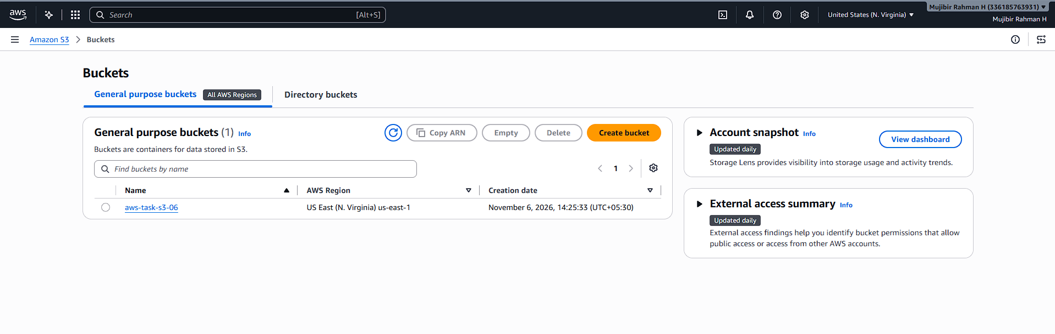
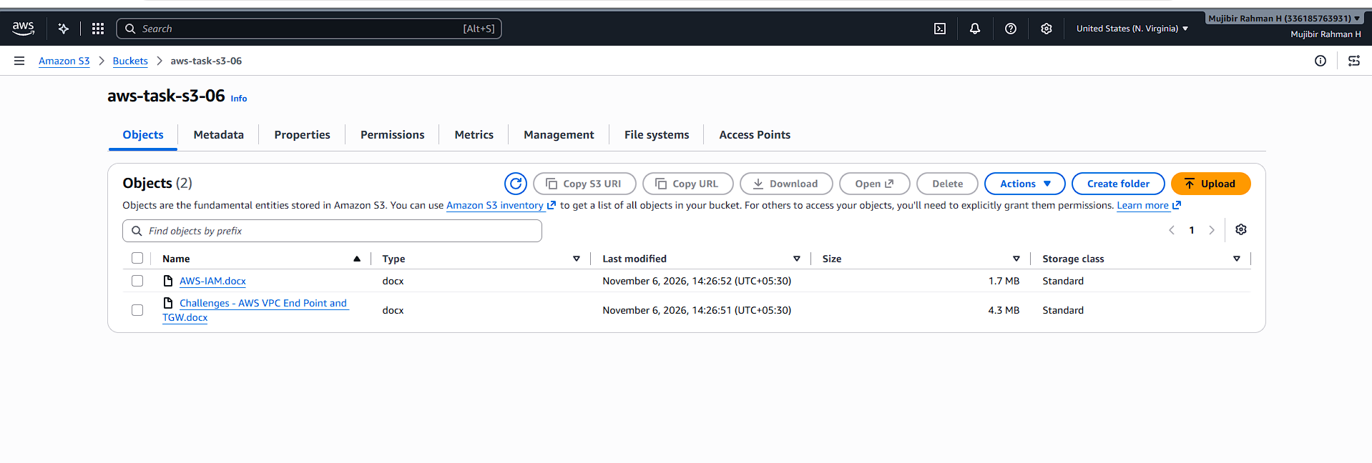
- Deploy a static website in the S3 bucket.
I create one more bucket for static website launch. I uploaded the html file which I have it in local.
I enabled the static website host and I updated the bucket policy. Without bucket policy also it will work.
I copied the static URL and tried it in browser. I accessed the html page.
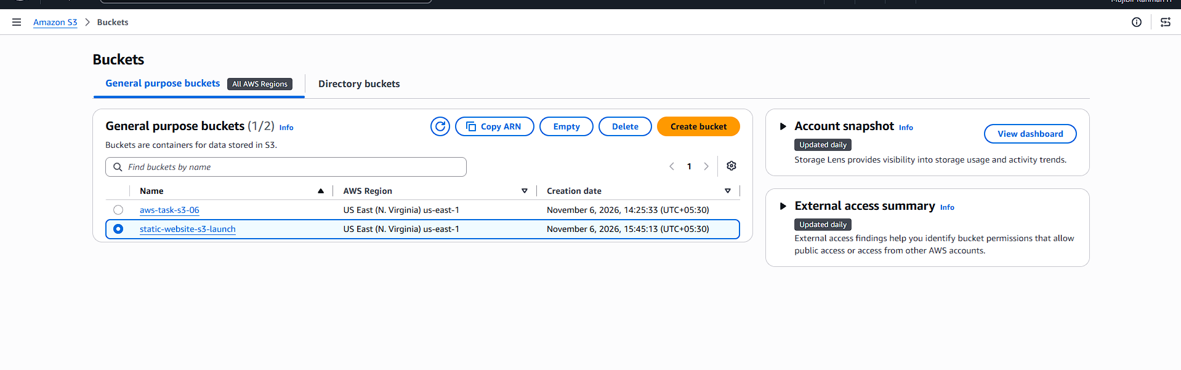
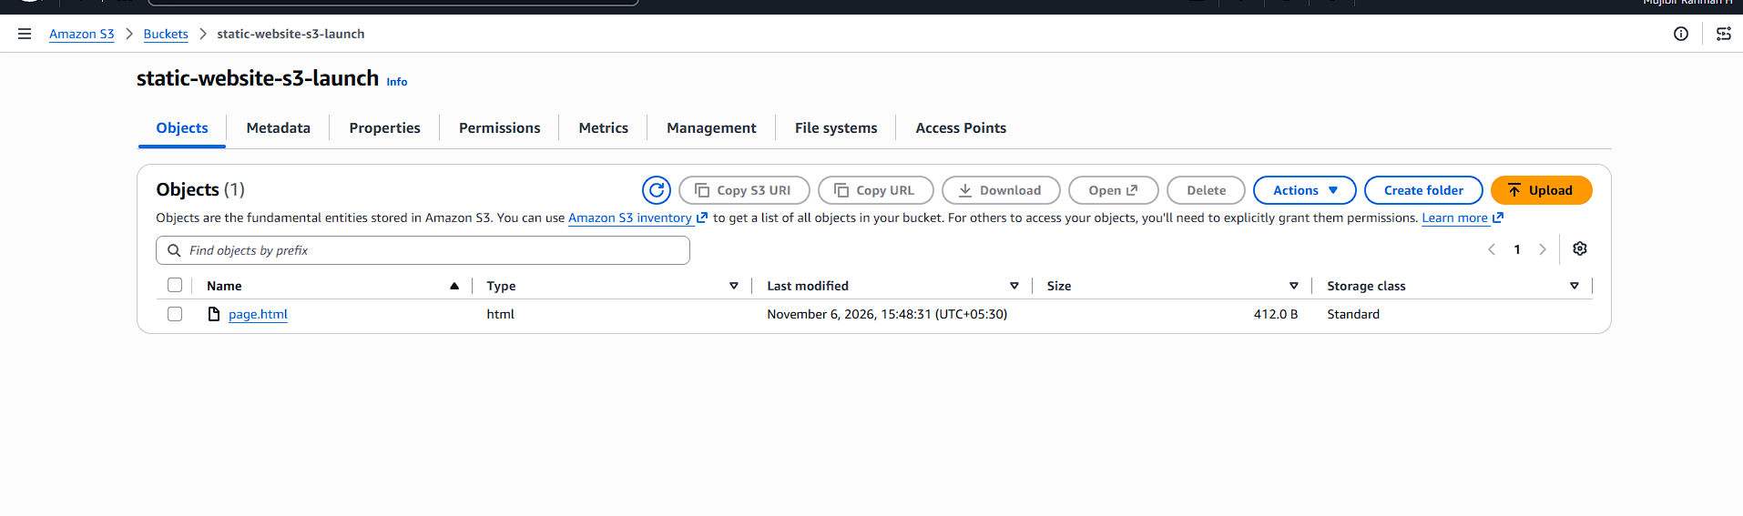
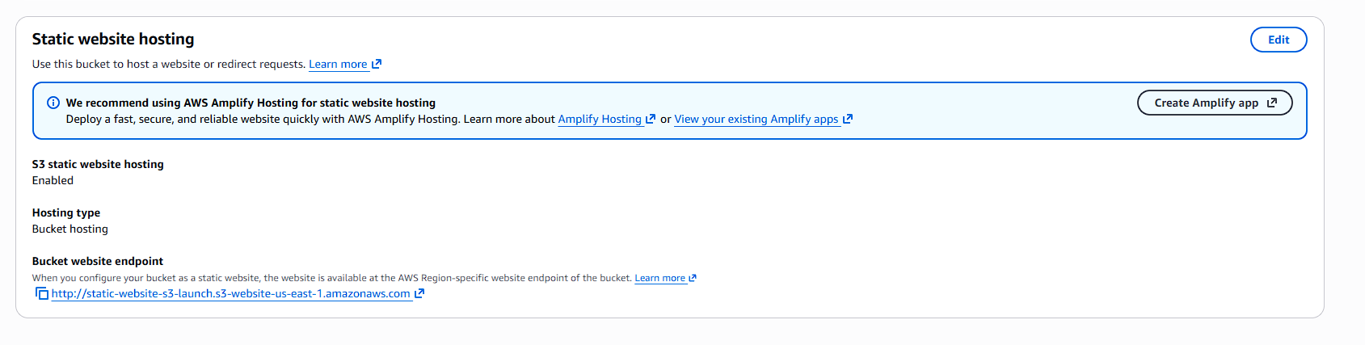
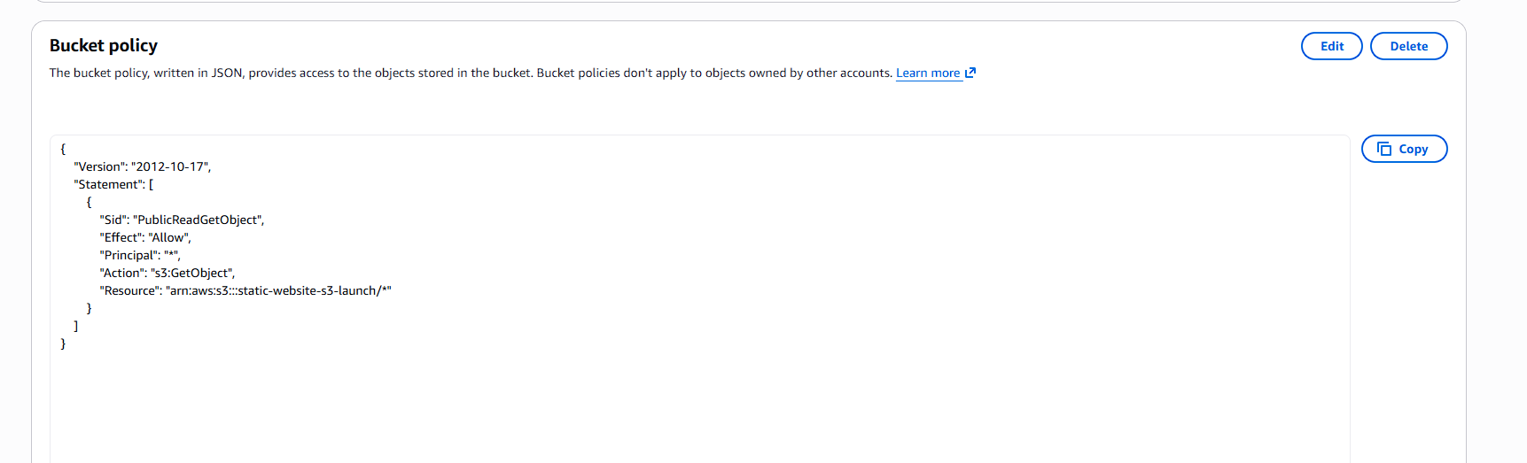
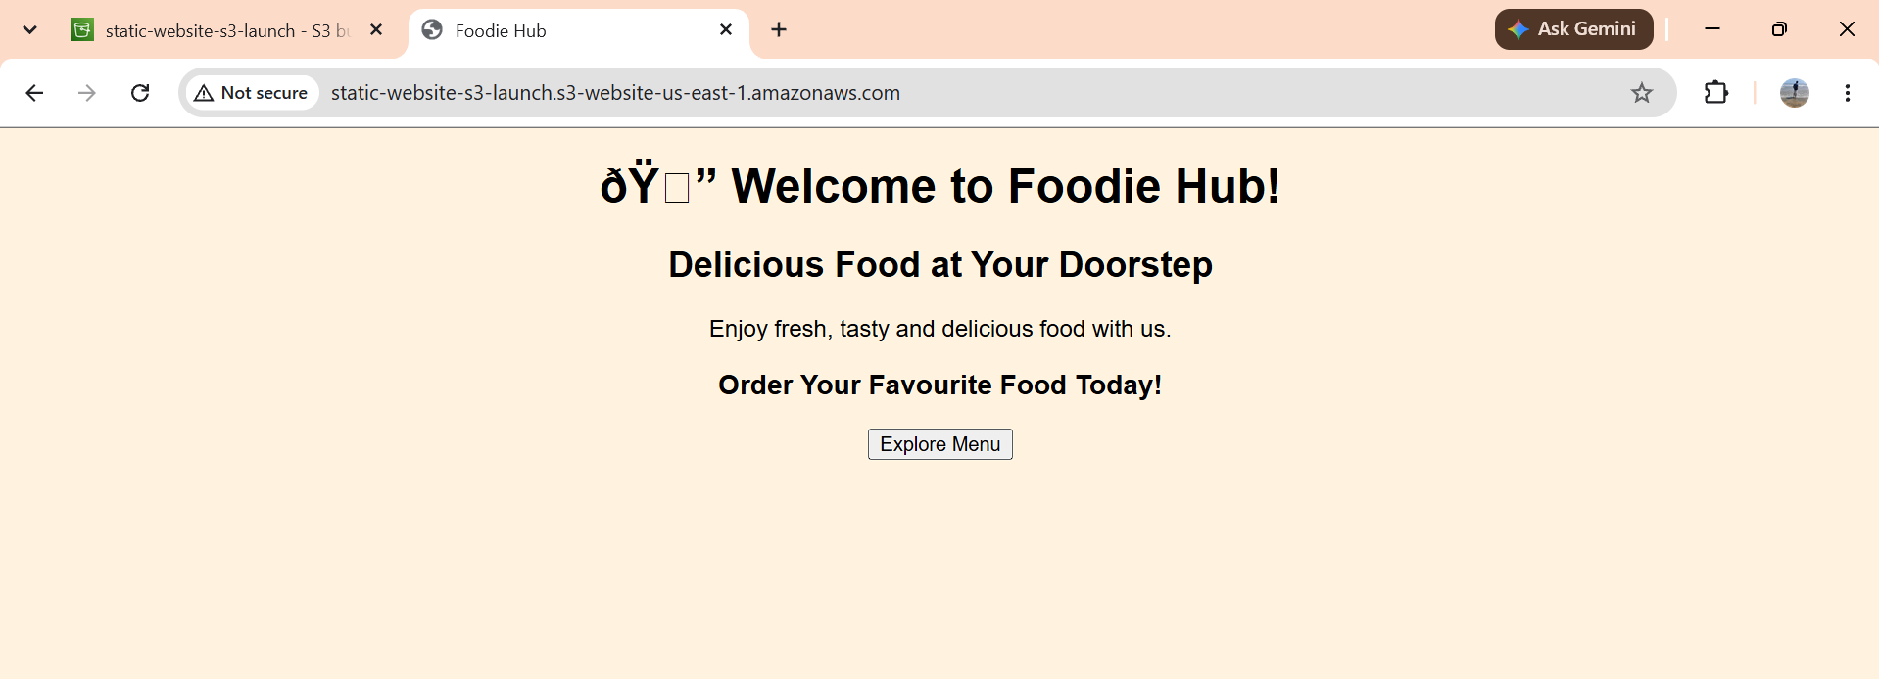
- Enable cross-region replication on S3 buckets.
I already have a bucket in N.Virginia region. So, I created one bucket in Sydney region.
while creating the both buckets, I enabled the bucket versioning.
I am going to use the replication logs. So, I made N.Virginia as a source and Sydney as a destination.
While creating the replication its asked for IAM role, I just gave create a IAM role. It’s automatically created the IAM role.
I uploaded one file in source and checked in the destination path. File replicated in destination.
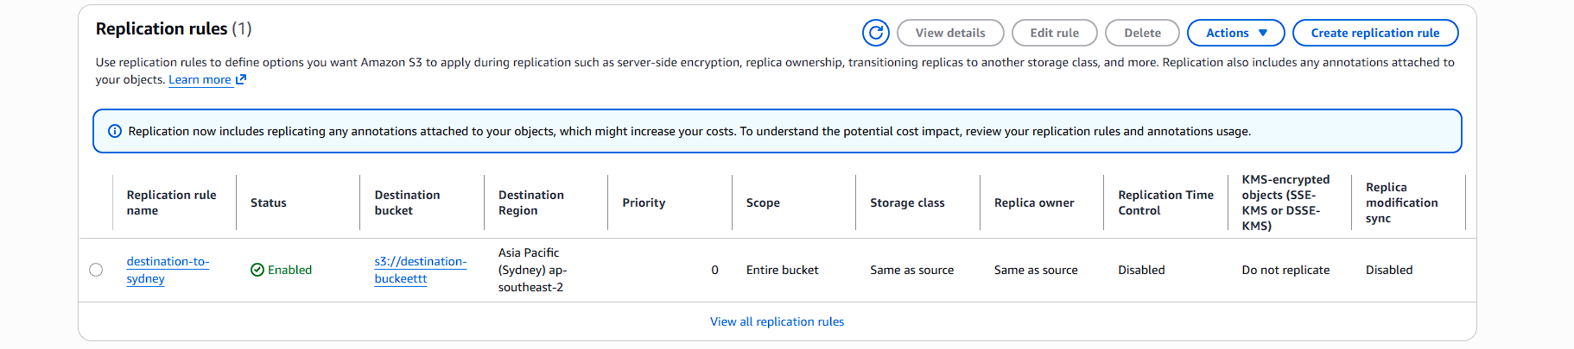
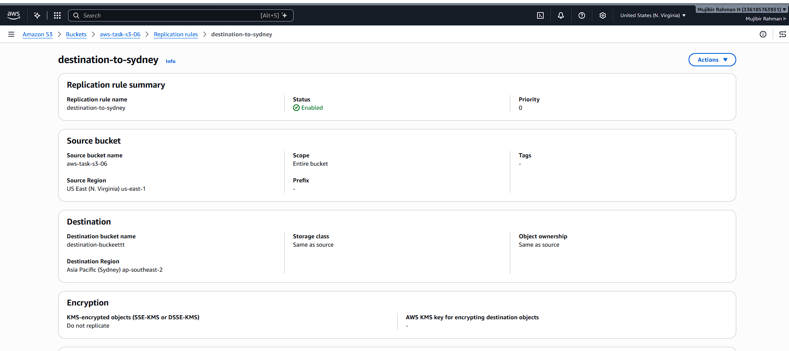
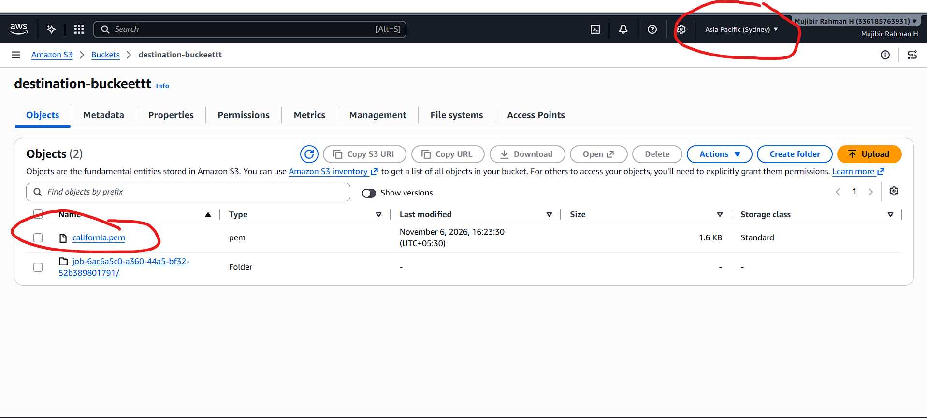
- Configure a bucket policy so only the Admin user can see the objects of the S3 bucket.
I created one IAM user and added the custom policy for accessing the particular S3 bucket. Added that policy to IAM user.
I am just created the S3 bucket policy for only that IAM user can view/access the files inside the bucket.
While Logging into IAM user using URL, I am able to see S3 bucket files.
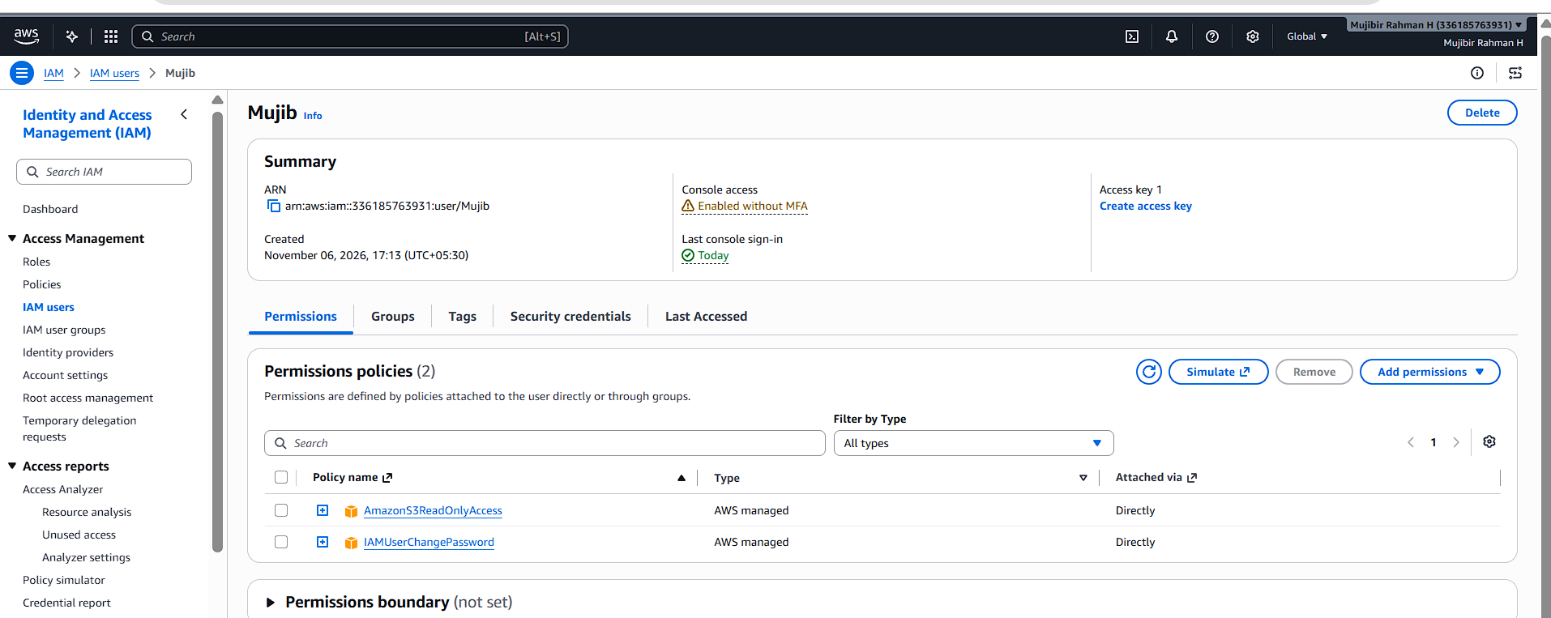
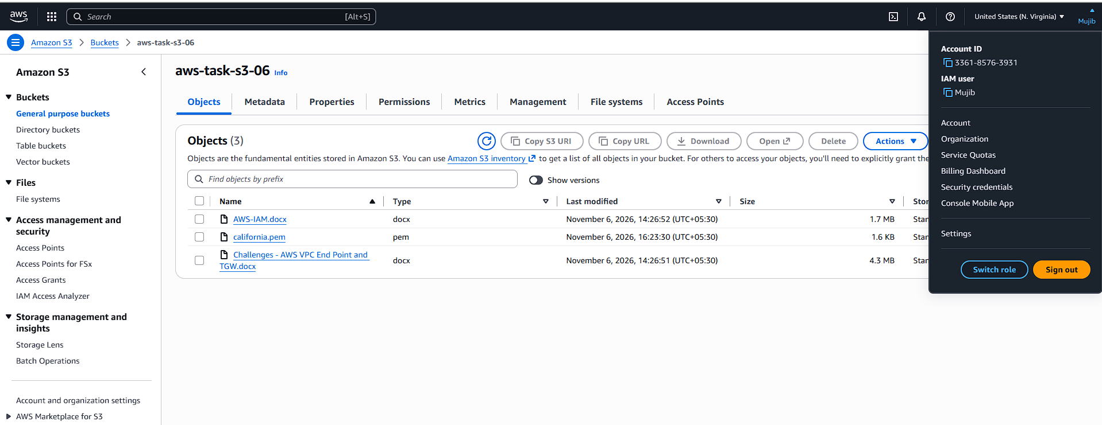
- Set up lifecycle policies to automatically transition or delete objects based on specific criteria.
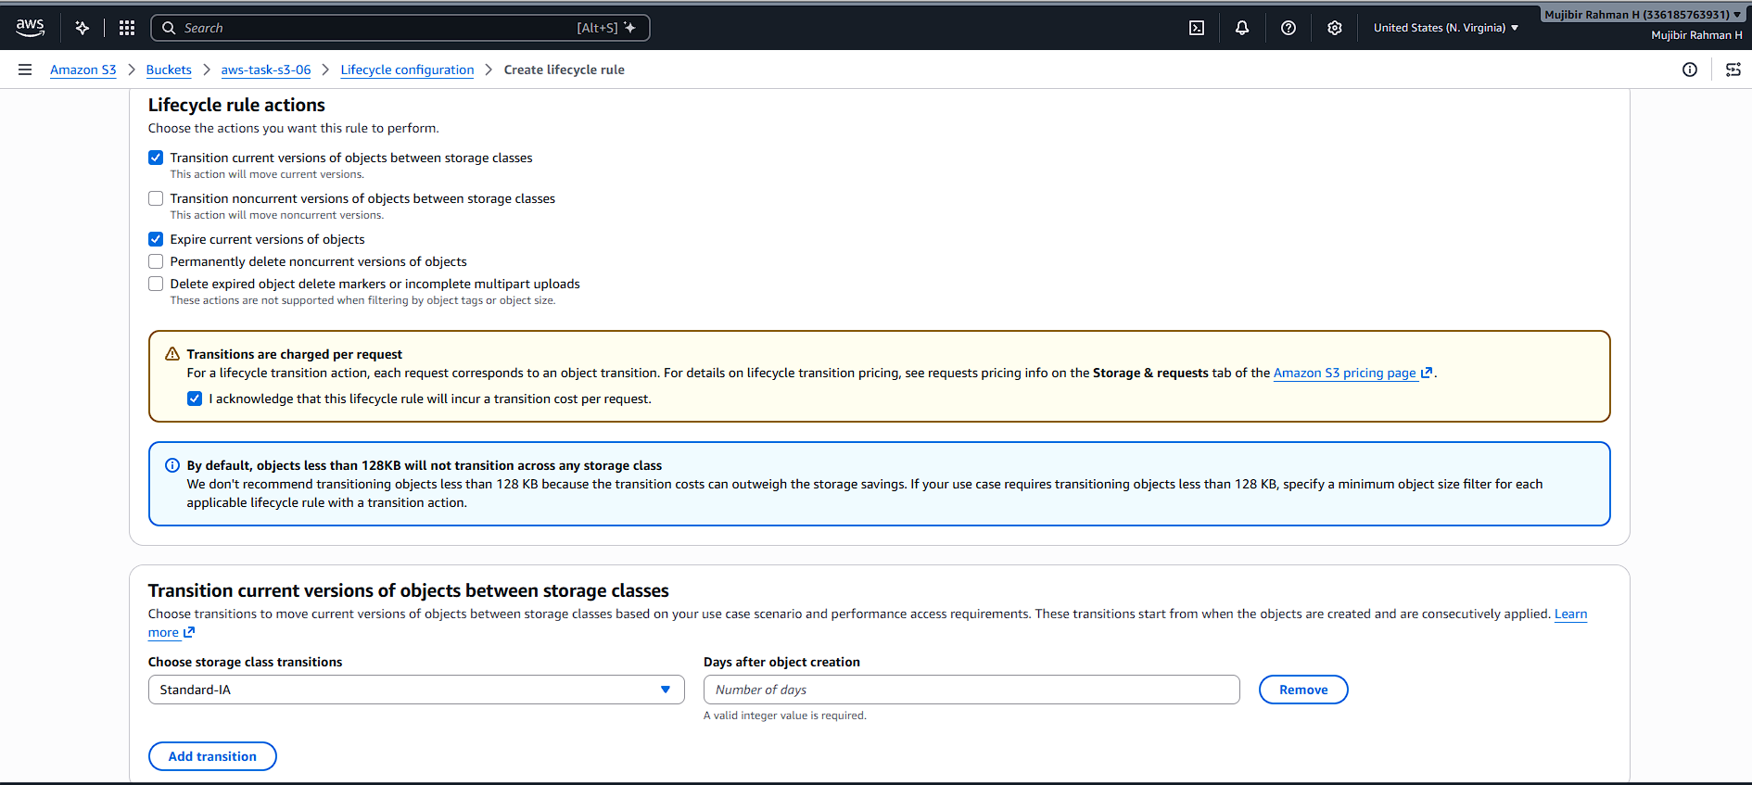
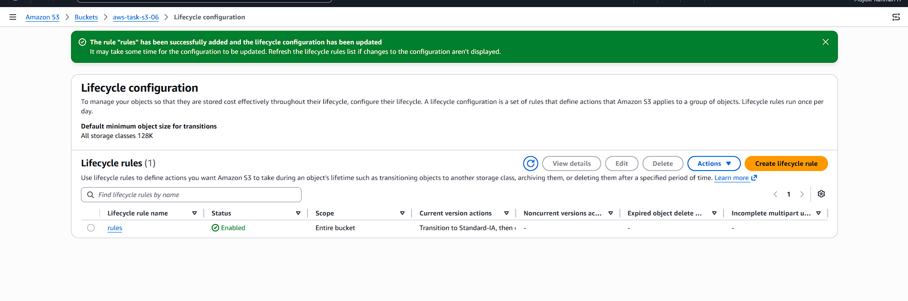
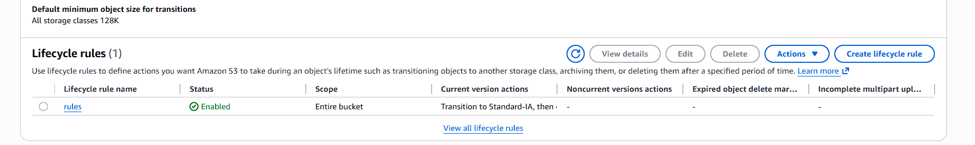
- Push some objects to S3 using the AWS CLI.
I just created one instance and try to configure the AWS in that instance with the help of access key and secret key.
I created the files in that and try to copy the files to s3.
Using this command aws s3 cp <file_name which file we want to copy&paste> s3:/destination path/
It’s worked.
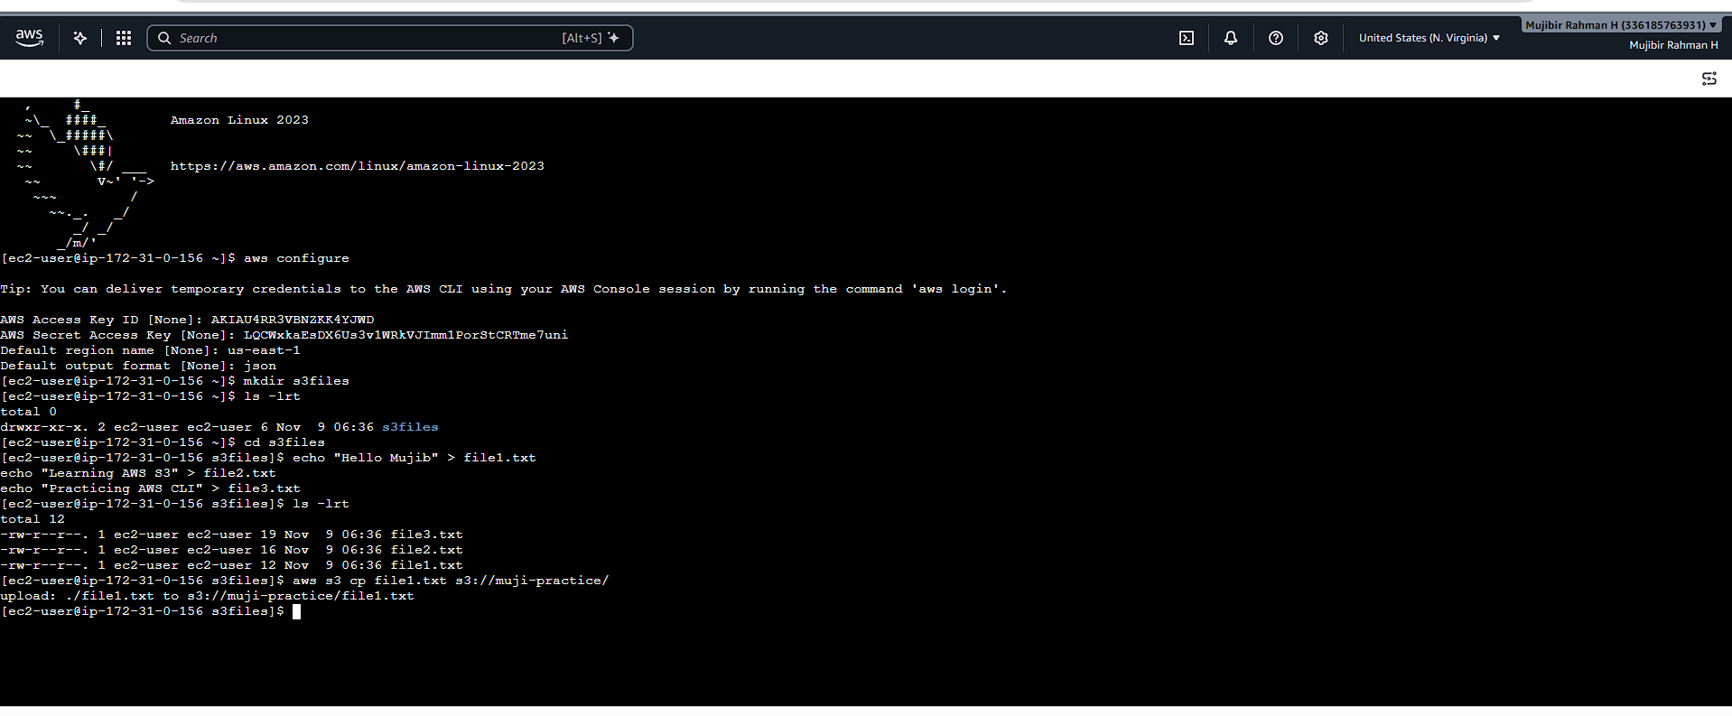
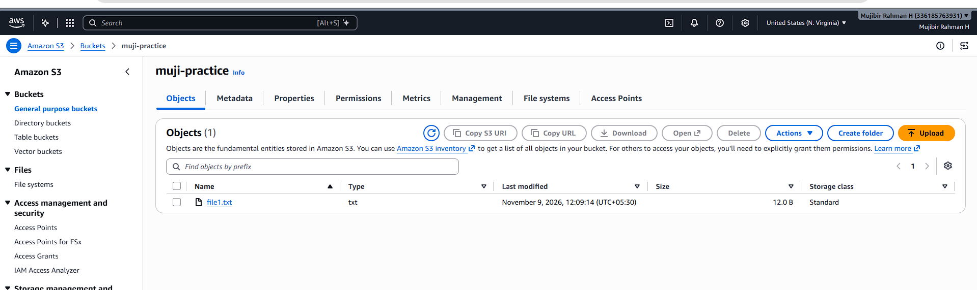
- Write a Bash script to create an S3 bucket.
I created one file for bash scripting to create one s3 bucket in AWS.
I executed the script file and given the required details, bucket was created instantly.
Able to see the bucket in AWS S3 console as well.
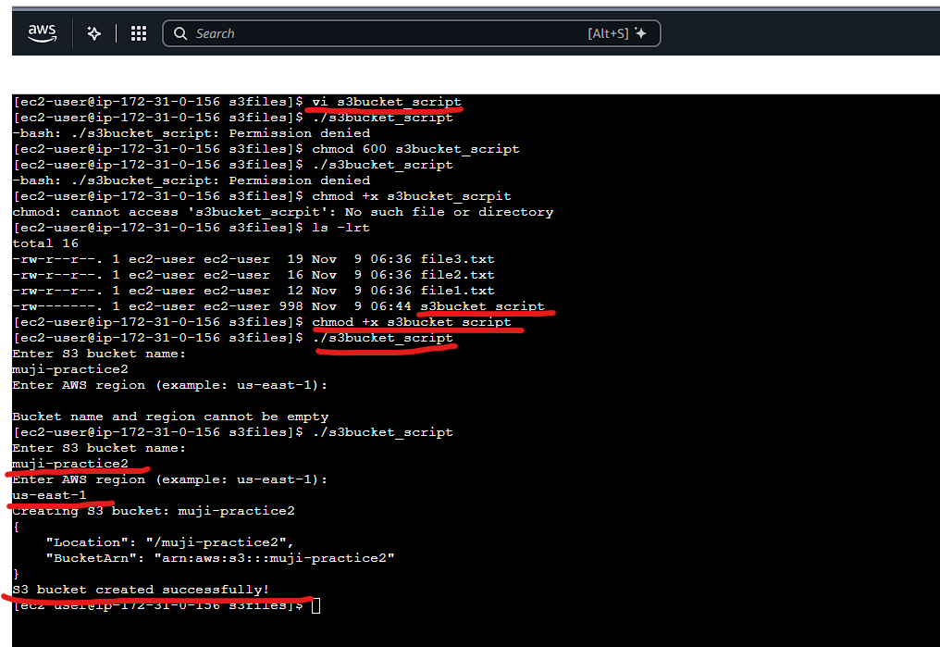
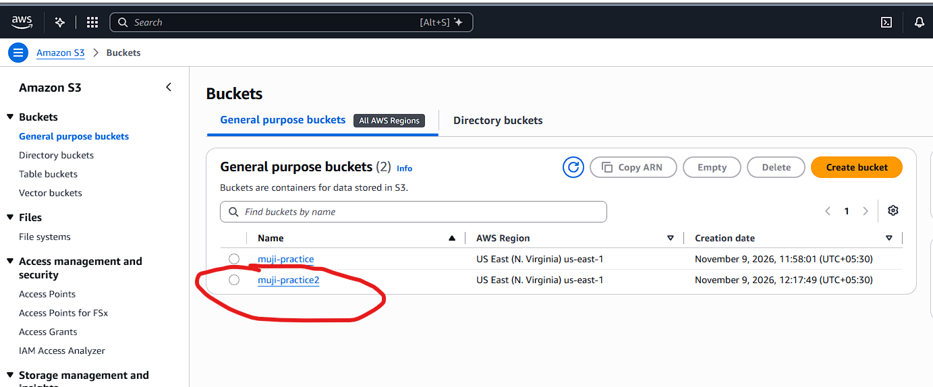
- Upload a 1 GB file to S3 using the CLI.
dd if=/dev/zero of=1_gb_file bs=1M count=1024
This above is for creating the 1GB file, then I just copied this files into S3 bucket.


